LIBRARY WEBSITE

**ABOUT THE PROJECT**

**Project Overview**

The library website project embarks on a mission to create an inviting and user-friendly online platform that caters to the diverse needs of book enthusiasts and library members in India. Rooted in simplicity and easy accessibility, the website seeks to replicate the warm and familiar experience of visiting a cozy library, providing a seamless transition to the digital realm. With a strong focus on fostering engagement, community building, and a love for reading, the project endeavours to become a vibrant hub for bibliophiles and knowledge seekers across the country.

**Project Scope**

In this fast-paced digital era, where technology forms the backbone of modern society, even our beloved book reading culture has witnessed a transformation into an exquisite online platform. Leading libraries across the world have embraced this digital revolution, creating their own online library platforms. These digital havens not only provide essential information about the library but also offer users the convenience of purchasing books and joining the library from the comfort of their homes.

To keep pace with the evolving needs of the community and embrace the digital wave, it is imperative to develop a captivating and user-friendly library website. Our project scope revolves around creating a beautiful online space that caters to the dynamic demands of modern readers and knowledge seekers.

The website will serve as a virtual gateway to the library, providing an immersive experience that preserves the essence of a traditional library while harnessing the potential of cutting-edge technology. Through an aesthetically pleasing design, the website will captivate users and draw them into a world of literary treasures and enriching resources.

One of the key features of the website will be its interactive and informative interface. Users will find comprehensive information about the library's offerings, events, and services, making it a one-stop destination for all their literary needs. A seamless navigation system will ensure easy access to various sections, such as "Home," "About Us," "Collections," "Events," and "Membership."

An essential component of the project will involve integrating an e-commerce functionality, enabling users to purchase books online. This convenient feature will attract book lovers from far and wide, expanding the library's reach beyond geographical boundaries.

To streamline library operations and enhance efficiency, the website will incorporate a robust cloud-based management system. This sophisticated algorithm will keep track of book withdrawals, returns, purchases, and member registrations. Such an advanced system will ensure smooth library management, leaving both staff and users delighted with the seamless experience.

Furthermore, the website will offer an engaging "Join the Library" section, enticing potential members with enticing benefits and privileges. By providing a straightforward registration process, we aim to make becoming a member an enticing proposition for readers of all ages.

In conclusion, our project scope revolves around creating a modern and enchanting library website that caters to the needs of the contemporary community of readers and learners. By blending tradition with technology, we aspire to transform the library experience into an alluring and accessible online platform. With a focus on user satisfaction, convenience, and efficiency, our website aims to redefine the concept of libraries, enriching lives and fostering a vibrant literary community in this digital age.

**GENERAL DESCRIPTION**

The project's central hub is the homepage, carefully designed to offer visitors a welcoming and intuitive starting point for their digital library journey. The homepage features a user-friendly navigation bar, comprising essential tabs like "Home," "About Us," "Collections," "Events," and "Login." Embracing a clean and clutter-free layout, the website aims to ensure that users can effortlessly find the information they seek, facilitating a smooth browsing experience.

At the heart of the website's appeal lies the captivating "Author of the Week" section. Through this special showcase, the website will introduce visitors to a diverse array of authors and their literary works. By spotlighting various writers from different genres, the project aims to spark curiosity and encourage readers to explore new books, broadening their horizons and discovering fresh perspectives.

Complementing the "Author of the Week" feature, the homepage boasts an interactive slideshow that presents users with three exciting options to explore:

1. Join the Library Membership: This section warmly invites visitors to join the library's growing community of book enthusiasts. With clear and concise information on the membership process and its associated benefits, the website aims to make becoming a member an attractive proposition for all who cherish the joy of reading. Membership unlocks a world of literary resources, events, and opportunities to connect with like-minded individuals.

2. What's New?/News and Updates: In this dynamic section, the website will keep users updated with the latest happenings and activities at the library. From announcements about upcoming book launches and literary festivals to details about enriching workshops and engaging programs, the "What's New?" segment will be a source of inspiration, encouraging members to actively participate and be part of the vibrant literary community.

3. Books Collection: The "Books Collection" segment promises a delightful exploration of the library's extensive catalogue. With glimpses into classic masterpieces, contemporary bestsellers, and a myriad of captivating reads, the website's virtual bookshelves will appeal to readers of all tastes and interests. This collection will serve as an invitation for users to immerse themselves in fascinating narratives and timeless knowledge.

Each of these enticing options will act as gateways, directing users to dedicated pages with in-depth information. The "About Us" page will warmly introduce visitors to the library's rich history and its unwavering mission of promoting literacy and knowledge sharing. The "Events" page will present an interactive calendar, brimming with upcoming workshops, thought-provoking book clubs, and other engaging literary gatherings. This thoughtful curation of events will inspire members to actively participate and share their passion for books and ideas.

To enrich the user experience further, the website will incorporate a secure and personalised login functionality. Registered members will gain access to their individual profiles, unlocking a treasure trove of customised services and benefits. From managing their borrowed books and tracking reading histories to receiving personalised book recommendations, each member will be treated as a unique individual, fostering a strong sense of belonging and kinship within the library community.

**Conclusion**

In conclusion, the library website project sets forth on a noble quest to create an enriching and interactive online space for all book enthusiasts in India. By blending simplicity, user-friendliness, and engaging content, the website aspires to kindle the flame of curiosity, ignite a passion for reading, and foster a vibrant community of knowledge seekers. Embracing tradition and technology, the project seeks to preserve the timeless charm of libraries while embracing the limitless potential of the digital age. With its warm and welcoming approach, the library website project aims to be a beacon of literary joy and a catalyst for positive change in the lives of all its users across the nation.

**USER INTERFACE DESIGN**

**PAPER LAYOUTS**

**REGISTER PAGE**

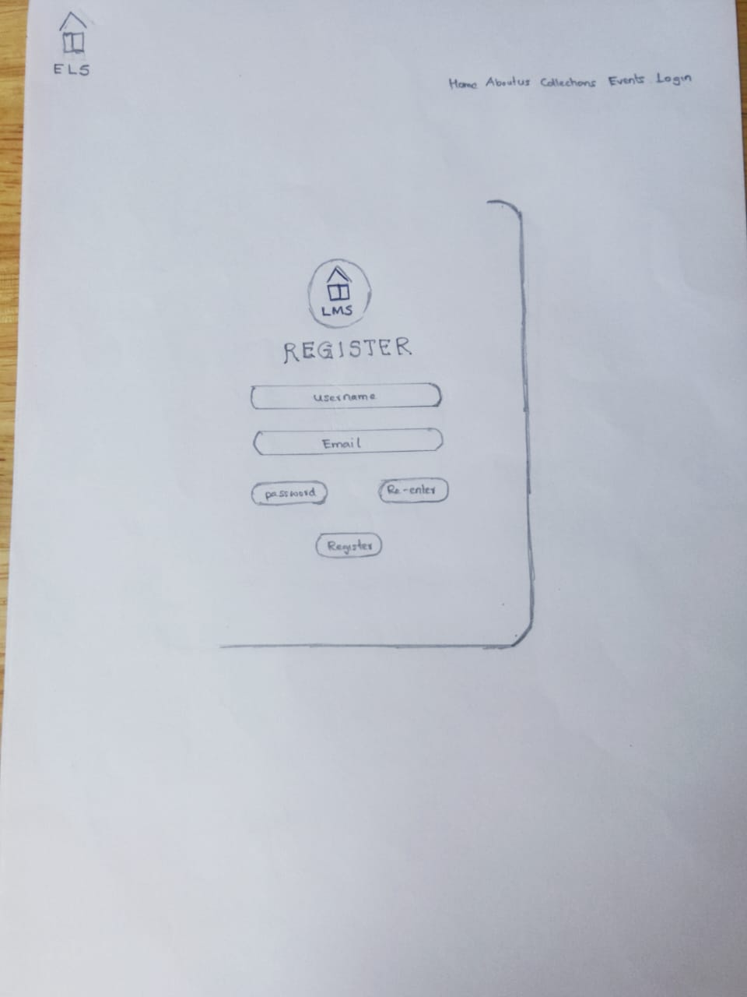

**LOGIN PAGE**

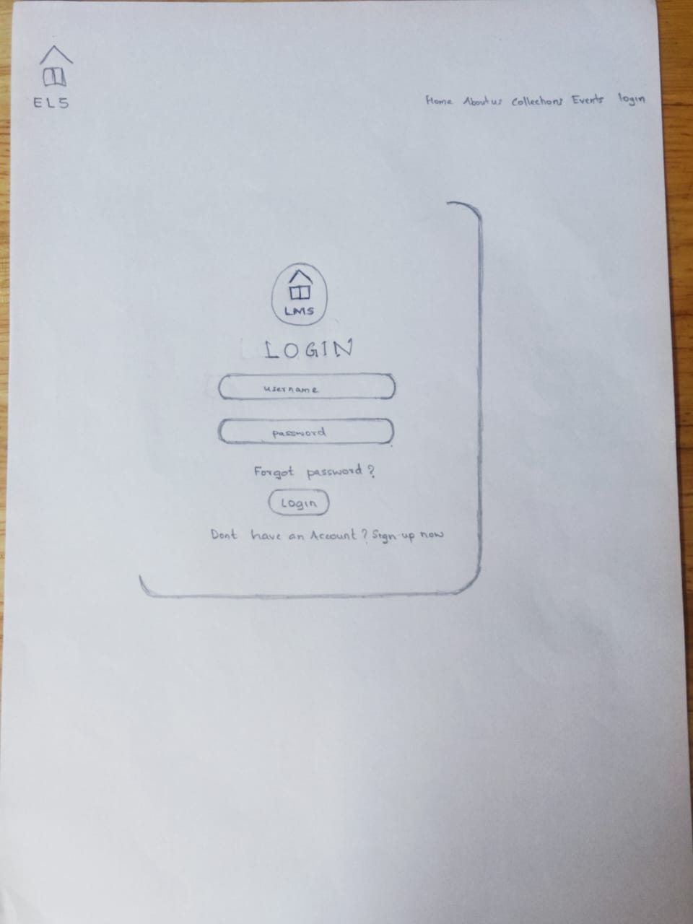

**HOME PAGE**

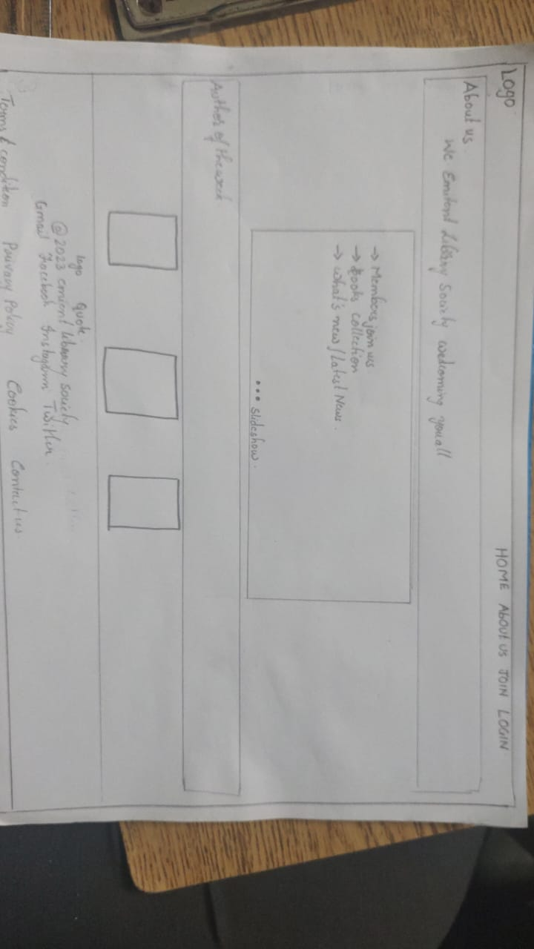

**COLLECTIONS PAGE**

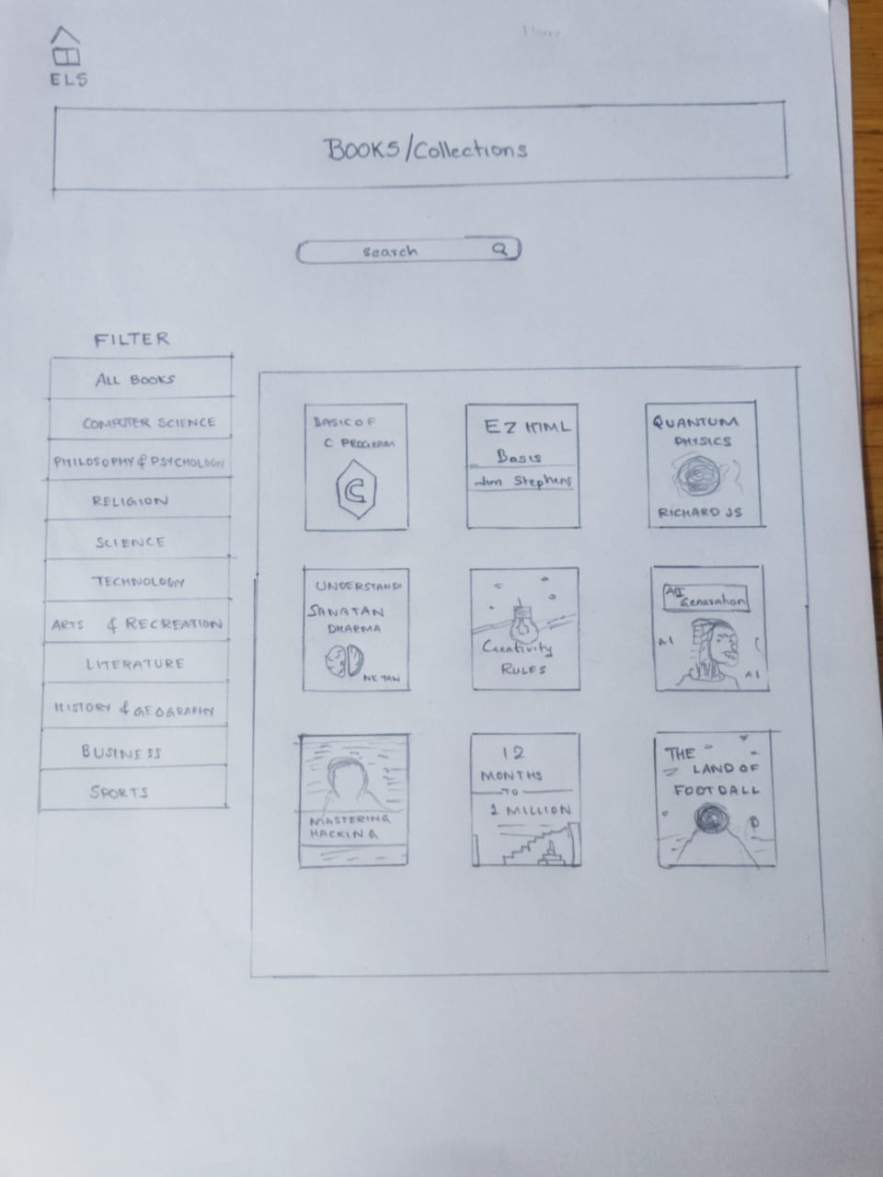

**Figma Design**

**REGISTER PAGE**

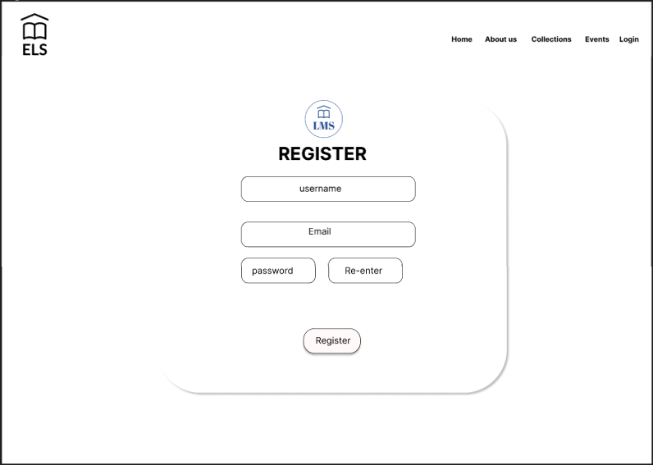

**LOGIN PAGE**

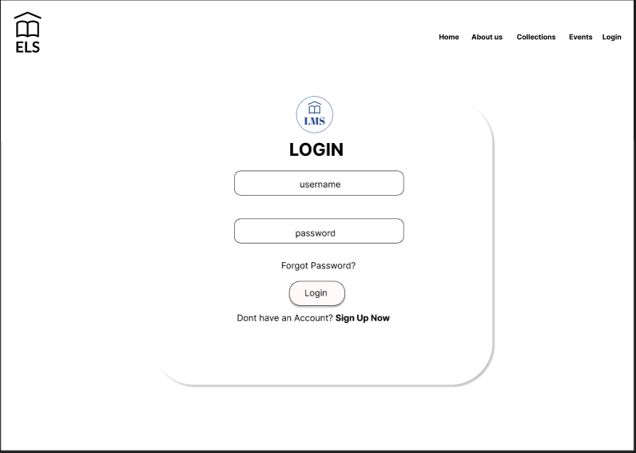

**COLLECTIONS PAGE**

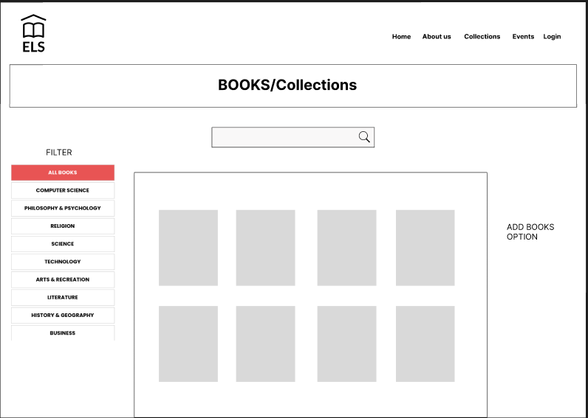

**HOME PAGE**



**DEVELOPERS WEBSITE**

AMARNATH KR **- AM.EN.U4CSE22304**

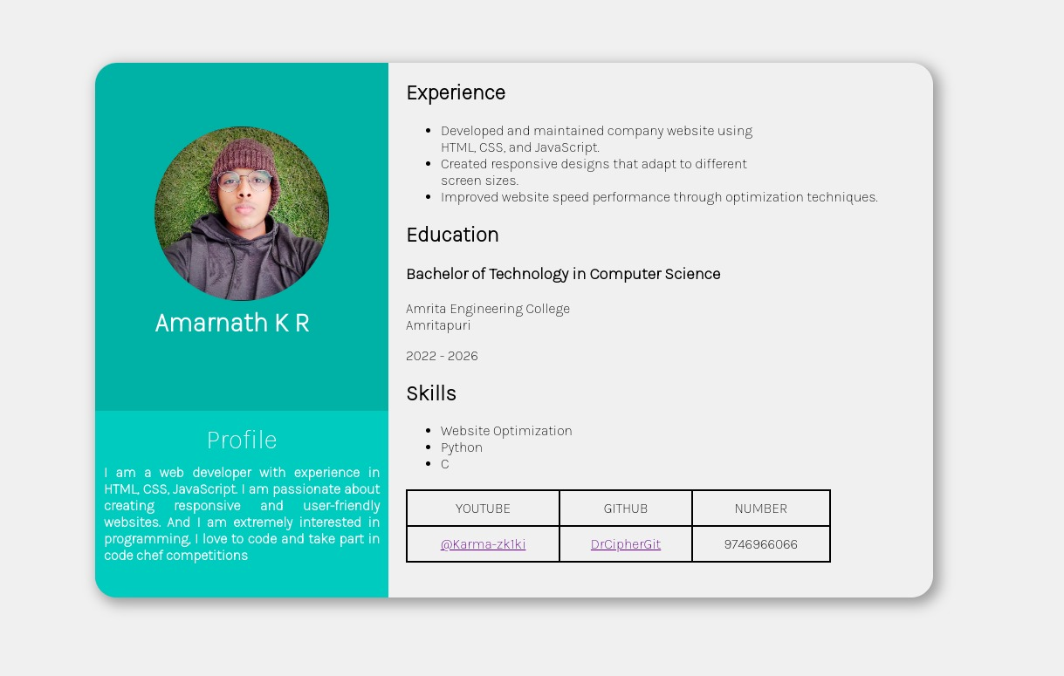

GOVIND KRISHNA - **AM.EN.U4CSE22322**

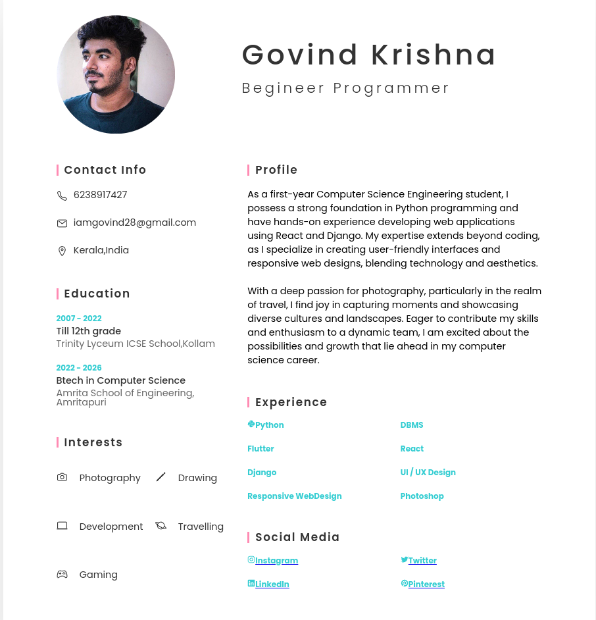

ANUROOP BRAHMANAND -**AM.EN.U4CSE22307**

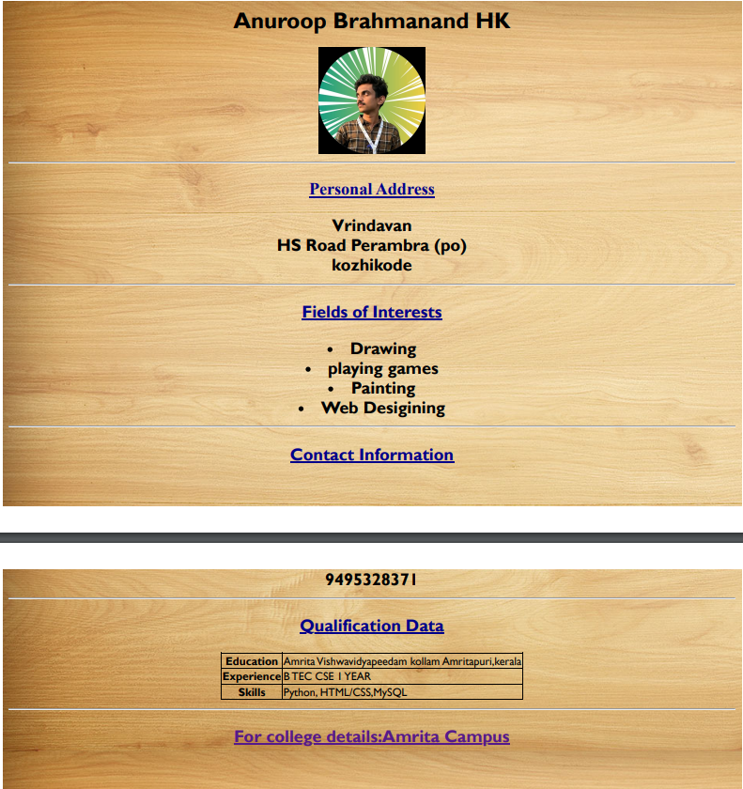

MEENAKSHI KODALI- **AM.EN.U4CSE22336+**

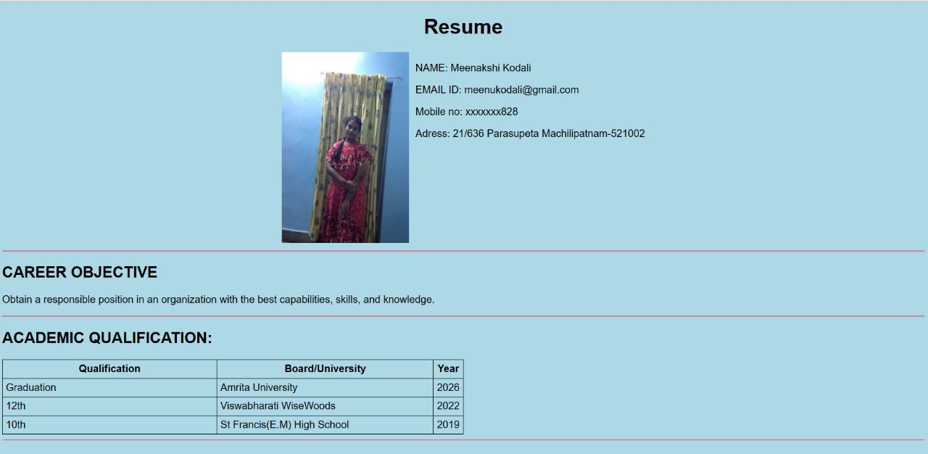  
  
  
NITHYA KEERTHANA - **AM.EN.U4CSE22331** 